New Developer Setup – 28 Apr 2015

This document has been re-written to be used primarily for brand new installations, as opposed to starting from an image where some setup has already been done.  
Note : You will need administrator access on the machine.

Contents

1. New T: drive mapping 2

2. Enable IIS (Internet Information Services) 3

3. Visual Studio 2012 4

4. Visual Studio 2010 Files 4

5. NANT 5

6. Perforce Source Control Installation 5

Visual Studio Source Control setup: 5

7. SQL Server 2008 6

Installing and Configuring SQL Server 2008 R2 6

Connection Options 6

Databases 6

Additional SQL Stuff 6

8. Get Latest Trunk 7

(a) Using Perforce 7

Or (b) Using Nant 7

9. Build Application 8

Opening solution in Visual Studio 8

10. Setup Application 9

Folder Permissions 9

Copy Dojo 9

(OPTIONAL) CKEditor 9

(OPTIONAL) Setting up the Web App in IIS 10

11. Running the Web App 11

Setting up ASP.NET 4 version to be available in IIS (especially application pool) 11

12. Re-sharper 12

13. Logging and Debugging 12

14. Aspose License 12

15. Development Environment Settings 12

16. “Compare…” in Visual Studio 12

17. Virtual PCs 12

APPENDIX 1. Using Perforce and Building the Web App without NANT 13

Build Solutions required for Web App 14

# New T: drive mapping

For the SAP domain, the T: drive is in a new location.

Steps:

1. Begin by entering the path  
   ‘\\orgbb-dscl\Development’  
   into a windows explorer window.

Note : will require username in the format ah_nt_domain\jsmith (for John Smith) and your SFSF domain password which is likely a different password to SAP domain password. If expired see <https://account.successfactors.com/help/user-guide/How-to-Change.html>

1. Right click the ‘Development’ folder in the left panel and select ‘Map Network Drive’.
2. Set this drive to T: drive.

*TODO:: Does this path work in other offices EG Bangalore?*

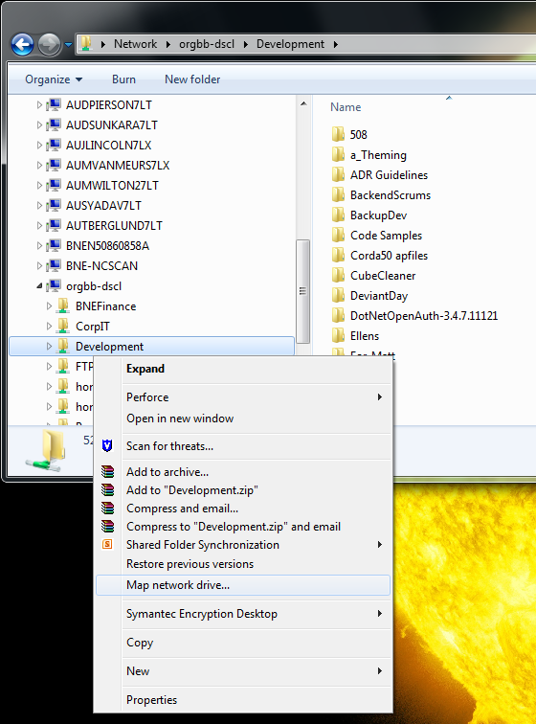

# Enable IIS (Internet Information Services)

This must be done before installing visual studio to avoid complications later.

Steps:

1. Go to Control Panel -> Programs and Features
2. Click ‘Turn windows features on or off’ on the left hand side.
3. Choose the features shown below.

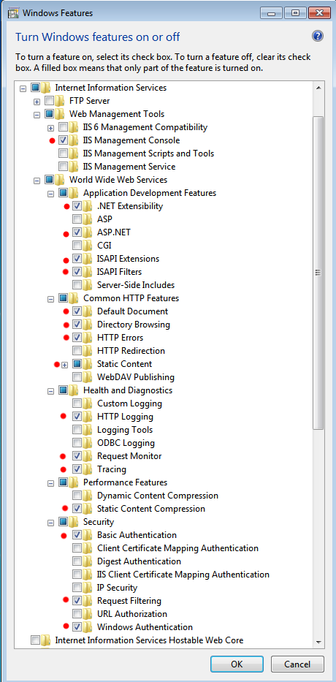

# Visual Studio 2012

Find the Visual Studio installer; this should be at T:\Setup\Development\Microsoft Visual Studio 2012 Professional\

***Note*** *: ENSURE* ***IIS*** *IS CONFIGURED BEFORE CONTINUING*

1. On the Choose Default Environment Settings, choose the General Development Settings option, as it includes the most options.
   1. This selects default IDE customizations, including fonts and colors, start page customizations, menu and keyboard customizations.
   2. You can change later via Tools > Import and Export Settings > Reset all settings > No just reset settings > and choose an option.
2. It is suggested that you do a custom install and exclude the SQL Server Express option.  
   You may also want to decide if you really need C++, VB and F#.  
   Feel free to install these if you are curious enough to use these in your own time.

Note : when opening Visual Studio may get error messages about not being compatible with the current version of windows. Ignore these and open anyway.

**(OPTIONAL) To change the colour / theme, go to:**

[Visual Studio 2012 Color Theme Editor](http://visualstudiogallery.msdn.microsoft.com/366ad100-0003-4c9a-81a8-337d4e7ace05)

Customisation of individual elements is possible.

**(OPTIONAL) If you don’t like how the menu is ALL_IN_CAPS**

1. Log in to Jam
2. Go to Inform Engineering Group
3. Go to Content/ Resources/ Settings
4. Download & unzip “VisualStudio2012-SuppressUpperCaseMenus.zip” and run it

OR

1. Apply this registry modification:   
   [HKEY_CURRENT_USER\Software\Microsoft\VisualStudio\11.0\General]  
   "SuppressUppercaseConversion"=dword:00000001

**IMPORTANT**

Remember to check your Visual Studio and Resharper settings before modifying any code.  
See the **Resharper and Visual Studio Settings** document on Jam (Inform Engineering/Content/Resources/Settings).

# Visual Studio 2010 Files

There is a dependency in some projects for some of the old Visual Studio 2010 files (EG Hrml.RemoteServices).

If at any time you see this error:

The imported project "C:\Program Files (x86)\MSBuild\Microsoft\VisualStudio\v10.0\WebApplications\Microsoft.WebApplication.targets" was not found.

You will need to perform the following steps:

1. Download the “VisualStudio v10.0 Skeleton.zip” file from Jam (Content / Resources / Settings)
2. Unzip this somewhere (you should get a ‘v10.0’ folder)
3. Copy this folder to “C:\Program Files (x86)\MSBuild\Microsoft\VisualStudio”, say Yes to replacing files/folders

Building through Nant or Visual Studio should now work.

# NANT

1. Navigate to T:\Setup\Development\Nant
2. Copy the Nant and NantContrib sub-directories to C:\Program Files (x86)\Nant
3. Set Environment variables required for Perforce. These are
   1. P4CLIENT = your machine name + _PWS e.g. “i072562_PWS” OR “johns_BNEN…_PWS” (check the name of your workspace)
   2. P4PORT = bnedevwfaperf01.successfactors.com:1666
   3. P4USER = your Perforce user name e.g. ‘johns’ OR ‘jsmith’
4. Set Environment variables required for NantContrib
   1. NANT_CONTRIB_HOME C:\Program Files (x86)\NantContrib
5. Add “C:\Program Files (x86)\Nant\bin;” to the end of the PATH variable

# Perforce Source Control Installation

1. Current version of P4V.exe is 2012.1.47.5402 as at Feb 2013.
2. Located at T:\Setup\Development\Perforce\2012.1 64bit\**p4vinst64.exe**
   1. Accept all defaults except  
      - change Server to bnedevwfaperf01.successfactors.com:1666  
      - change Editor if you wish  
      - set username to your Perforce user, ask someone else to check for you
   2. Yes to replace SCC (if required)
3. Install p4sccinst.exe Located at T:\Setup\Development\Perforce\2012.1 64bit\**p4sccinst.exe**This is the plugin for Visual Studio.
4. Setup Perforce:
   * + 1. Open p4v
       2. Run through the wizard: Don’t download files yet.
       3. Menu: Connection > Edit Current Workspace
       4. Change Workspace root to C:\PWS.
       5. Clean out anything currently in C:\PWS
       6. No need to get code yet, will be asked to in step 8 : Get Latest Trunk.

## Visual Studio Source Control setup:

Apply the following settings in Visual Studio.

1. Change the settings in Visual Studio under Tools – Options - Source Control - Environment
   * Checked-in item behaviour  
     On Save and On Edit: “Prompt for check out”
2. then, in Source Control – Plug-in Selection
   * select “Perforce SCM” (Can only be done after installing **p4sccinst.exe**, see ‘Perforce’ below.)
3. then, in Source Control – Plug-in Settings
   * Uncheck “Background updates”
   * If required, change user id from I number to perforce username

Open advanced and tick “Warn when files are checked out by other users”

# SQL Server 2008

## Installing and Configuring SQL Server 2008 R2

1. Installer located at T:\Setup\SQL Server 2008 and execute the **setup.exe**
2. Once loaded, select the ‘Installation’ tab on the left of the installer.
3. Select the first option (New SQL Server Stand-alone…)
4. Select all defaults until ‘Feature Selection’: select all *Shared Features*.

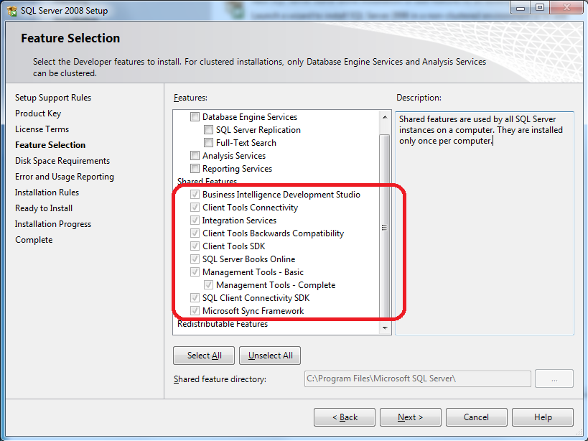

1. Continue onwards and finish the installation.

## Connection Options

Note **:** that with the move to the SAP domain, we can no longer use Windows Authentication to access the QA Boxes.

It should soon be possible to use Windows Authentication while connecting to local instances (EG BNEDEVWFASQL01 or BANGWFAPSQL01).

However, access to QA boxes you will need a special login from Terry, which you will need to enter when connecting by choosing ‘SQL Server Authentication’.

## Databases

* BNEDEVWFASQL01 – Brisbane
* BANGWFAPSQL01 – Bangalore
* DEVWFASQLQA01 – QA (Raging Wire)

## Additional SQL Stuff

1. Installers located in T:\Setup\Microsoft SQL 2008\SSAS
2. Install all 3, accepting default options.

*TODO:: What is this required for exactly? WST stuff only, or running SSIS packages??*

# Get Latest Trunk

## (a) Using Perforce

1. Open Perforce
2. Select the ‘Depot’ tab at the top of the left navigation tree
3. Right click and ‘Get Latest Revision’ on
   1. Assemblies
   2. Common
   3. Front Office -> Devel
   4. Front Office -> Common

## Or (b) Using Nant

1. Open up a command prompt and run the following commands.
2. After each nant command you should see ‘BUILD SUCCEEDED’.  
     
   p4 sync //depot/FrontOffice/Devel/Main.build  
   cd C:\PWS\FrontOffice\Devel  
   nant sync

# Build Application

Building the application is done easiest using Nant (*for manual build, see end of document*).

1. Open up a command prompt and run the following commands.
2. After each nant command you should see ‘BUILD SUCCEEDED’.

cd C:\PWS\FrontOffice\Devel  
nant build-release   
nant build-debug

*If you see a build error for SqlServerDatabaseUtil: ‘The type or namespace name 'Server' could not be found’; then you need to install SQL Server Management Studio. See the SQL Server 2008 heading above.*

## Opening solution in Visual Studio

Now make sure the application will open and build in Visual Studio.

Follow the following steps:

1. Open the HrmlWebApp.sln solution at C:\PWS\FrontOffice\Devel\HrmlWebApp
2. If you get an error when opening the solution:  
   The Web Application Project HrmlWebV9 is configured to use IIS.  
   Unable to access the IIS metabase. You do not have sufficient privilege to access IIS web sites on your machine.
   1. Navigate to this location  
      C:\Windows\System32\inetsrv\config
   2. You will be prompted to gain access to the directory permanently. Accept this.
   3. Also double check your Web Application in the IIS is configured to use .NET version 4 application pool (See Setting Up the Web App in IIS section further along.)
3. Make your web.config **NOT** read-only as follows
   * Navigate to web.config in Windows Explorer  
     (open web.config in Visual Studio -> right-click its document tab -> select Open Containing Folder)
   * Right-click the file and Properties  
     Un-tick the Read Only checkbox. Click Ok.
   * Do not fail to do the above, it is important.
4. Obtain an up-to-date web.config file from another developer
5. Build the HrmlWebApp.sln.

#### (OPTIONAL) Resources (images etc.)

Note : This is not required for the App to run, and cannot easily be done on the SAP laptops.

If **balnaves** machine is unavailable, then obtain the latest resources from another developer.

1. Copy the following directories from \\balnaves\balnaves.infohrm.com\PrePub\WebApp\Resources to C:\PWS\FrontOffice\Devel\HrmlWebApp\HrmlWebV9\Resources
   * LoginImages
   * MemberImages
   * Images\WFPImages (copy to Resources\Images\WFPImages)

# Setup Application

In order to run the application you need to set it up in IIS, configure some folder permissions, and copy some stuff from T:\

## Folder Permissions

1. Navigate to C:\PWS\FrontOffice\Devel\HrmlWebApp in Windows Explorer.
2. Right click HrmlWebV9 -> Properties.
3. On the Security Tab, click ‘Edit’
4. Ensure the following accounts exist with the specified permissions as a minimum.  
   Click ‘Add’ to add any that are missing.
   * **NETWORK SERVICE** – Read
   * **MachineName\Users** – Defaults (Read and Execute, Read, List folder contents)
     + To find this, click ‘Add’ -> Locations -> Select your computer -> OK  
       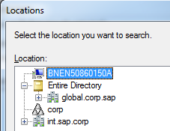
     + Type ‘Users’ into the available field and click ‘Check Names’  
       The word ‘Users’ should become Under-lined, and may get your machine name pre-fixed.  
       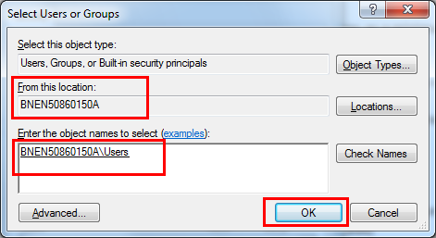
     + Hit OK.
   * **MachineName\IIS_IUSRS** – Full
   * **MachineName\IUSR** – Full

## Copy Dojo

1. Navigate to T:\Setup\Development
2. Determine which Dojo version we are using by double checking with someone (As of October 2012 we have changed to dojo-1.8.0)
3. Copy T:\Setup\Development\<Dojo-Latest>\*.* to C:\PWS\FrontOffice\Devel\HrmlWebApp\HrmlWebV9\Resources\dojotoolkit

## CKEditor

Formerly the FCK editor.

1. Open T:\Setup\Development\FCKEditor\
2. Up to b1502 we used version 3.6.3 and from b1505 on it is v4.4.7 (needed for IE11)
3. Extract the files from the archive “ckeditor_4.4.7_full.zip” (was “ckeditor_3.6.3.zip”) to the directory   
    C:\PWS\FrontOffice\Devel\HrmlWebApp\HrmlWebV9\   
   *\*\* Make sure you ACCEPT overwriting existing directories, but* ***DECLINE*** *to overwrite any existing files.  
   ** If using WinZip be sure to tick “use folder names” when extracting*  
   note that the zip includes “ckeditor” in the path, so this will create (or replace)  
    C:\PWS\FrontOffice\Devel\HrmlWebApp\HrmlWebV9\ckeditor

Note : If you do not copy the CKEditor as described above, the application will still work but any screens which use the CKEditor will not work. It is recommended you follow these steps to ensure no problems arise in the future.

If you accidentally overwrite the files, run P4V Perforce, and in the Depot go to //depot/FrontOffice/Devel/HrmlWebApp/HrmlWebV9/ckeditor/

then Get Revision, Get latest revision, and tick Force Operation. This will restore the source code controlled versions.

## (OPTIONAL) Setting up the Web App in IIS

1. Create the folder C:\inetpub\wwwroot\Devel (navigate there with windows explorer).
2. Open IIS
   * ControlPanel -> Administrative Tools -> Internet Information Services  
     or
   * Start -> Run ‘C:\WINDOWS\system32\inetsrv\inetmgr.exe’
3. Expand MachineName -> Sites -> Default Web Site -> Devel
4. Right click Devel -> Add virtual directory
   * Alias = HrmlWebV9
   * Directory = Browse to C:\PWS\FrontOffice\Devel\HrmlWebApp\HrmlWebV9
   * Accept default permission
5. You might get two folders showing, just close IIS and restart to fix this glitch.
6. Check the properties of the virtual directory.  
   These are set at various levels of the Connections tree on left.
   * [select the Devel folder] Double-click HTTP Response Headers > Set Common Headers (in Actions on right) > tick the Expire Web content + Expire Immediately
     + If you get this error (Insufficient Permissions)  
       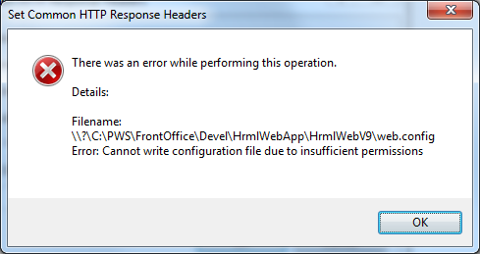  
       * Ensure web.config is NOT read-only  
       * Double check your security settings on the HrmlWebV9 folder
   * [at the top node, above App Pools] Need “default.aspx” as the first entry in the default documents. Double-click the Default Document icon. Use the “Move Up” on the right to make default.aspx the first.
   * [at “HrmlWebV9” node] Ensure it is using ASP.NET version 4 … click “Basic Settings” on the right, note the value for Application pool (e.g. “DefaultAppPool”). Dismiss the dialog. Click on Application Pools node. Check the .NET Framework version for the app pool entry.

# Running the Web App

Open the solution in visual studio and attempt to Run it.

1. Make sure HrmlWebV9 project is set as the startup project.
   * Right click the project in the solution explorer -> Select ‘Set as startup project’
2. Try running the app (F5)   
   *Note : If you get error at runtime about integrated authentication:*
   * *Open IIS -> Websites -> Devel -> HrmlWeb9 -> Properties*
   * *Directory Security -> Click Edit… on ‘Enable Anonymous Access… (etc)’*
   * *Tick the ‘Enable Integrated Authentication’ box.*
3. If successful, a webpage should popup with the infohrm login page.

Note : For IIS 7, the setting for “Enable Anonymous Access” is located under ‘Authentication’

Note : To run in debug mode, must run Visual Studio as an administrator. If you don’t you will get an error message about not being able to start debugging on the web server. Right click the icon in the start menu and select ‘Run as Administrator’.

If you get an error, run the fix below. It has worked for multiple different errors so far.

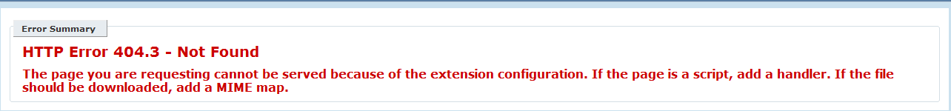

### Setting up ASP.NET 4 version to be available in IIS (especially application pool)

You must have installed Visual Studio before the IIS was configured correctly.

1. You will need to run a command prompt window AS ADMINISTRATOR.
2. Navigate to C:\Windows\Microsoft.NET\Framework64\v4.0.30319 (or similar v4.x.xxxx)
   * Run the tool aspnet_regiis with the parameter ‘i’
   * EG: type ‘aspnet_regiis –i’

This should setup the IIS and the app should run.

# Re-sharper

1. Install ReSharper, located in  
   “T:\Setup\Development\ReSharper” or “I:\ReSharper”  
   -- use the most recent installation file
2. The ‘license.txt’ is located in the same folder. Use the license with your name against it.
3. Select ‘ Resharper 2 Intelij IDEA’ as the keyboard shortcut mapping.
4. To import the Resharper rules that are compatible with the Infohrm coding style, import the following xml:   
   "T:\Setup\Development\ReSharper\Settings\Resharper-v61-settings-DaveP.DotSettings".   
   To do this, go to Resharper -> Manage Options –> Import / Export Settings and click on the Import button.

# Logging and Debugging

1. Create the error log directory as in the LogDir entry in web.config. For example  
    <add key="LogDir" value="C:/Temp/Debug"/>  
   you need to create the **C:\Temp\Debug** folder.
2. Enable script debugging in Internet Explorer.
   * Under the Tools menu select Internet Options.
   * Go to the advanced tab.
   * Uncheck the “Disable script debugging (Internet Explorer)” option under the Browsing group.

# Aspose License

1. Navigate to "T:\Setup\Development\Aspose"
2. Copy **Aspose.Total.lic** to **c:\windows\system32\Aspose.Total.lic**

This is needed for Word, PDF,PPT and Excel and is ref’d by line in your Web.Config file   
<add key="AsposeTotalLicence" value="C:\windows\system32\Aspose.Total.lic" />

*And yes, the misspelling of ‘Licence’ is correct for this setting.*

# Development Environment Settings

Set your development environment settings in accordance with our code hygiene standards.

1. Download the ‘*Resharper and Visual Studio Settings.*docx’ via the JAM located under ‘Content/Resources’ in the Inform Engineering Group.
2. Afterwards, follow the instructions set out in the document

These settings should be applied before you attempt to make any code changes.

# “Compare…” in Visual Studio

Before you check-in every file, you will want to compare it to the Source Code Control version to double-check your changes.

Out of the box, Perforce seems to have the “diff” application already set up, however, in Visual Studio to compare your file against the version in Source Code Control – which you will do every time before check-in – you may need to set the application.  
If you try “Compare” and a dialog appears “Locate P4Merge” you should navigate that dialog to "C:\Program Files\Perforce\p4merge.exe" and click Ok.

# Virtual PCs

Virtual PCs are required so that multiple versions of internet explorer can be run to test the web application in.

There is another document on SharePoint in [Home](https://portal.infohrm.com/) > [Development](https://portal.infohrm.com/Development/) > [Shared Documents](https://portal.infohrm.com/Development/Shared%20Documents/Forms/AllItems.aspx?View=%7b238BE040%2d1CDE%2d476A%2d8446%2dCA9628C28A61%7d) > Front Office > Testing with IE6 that details the setup procedure for Virtual PC.  
That document also covers testing in IE8.  
To recap, all web UI work must be tested against IE6, IE7, IE8 and Firefox. IE6 is not necessary for any RUI work.

# APPENDIX 1. Using Perforce and Building the Web App without NANT

You will need to use Perforce from time to time to manage your source control.

Start Perforce.

**Background:**

Unlike SVN which stores the status control files entirely on your PC, Perforce maintains the primary control list on the server. This means if you “Get Latest”, then delete your files, and “Get Latest” again nothing happens (you need Get Revision – Latest Revision – Force operation in this case).

Perforce stores this status against a combination of both the User and Workspace (the PC).

First thing is you need to do, is set up a Connection for your combination.

**Set up a Connection**

In P4V, Connection > Set Up Connection and follow the wizard.

Server / Port: bnedevwfaperf01.successfactors.com / 1666.

User: Terry should have set you up as a user, click Browse.

Workspace: Create a new workspace if there is not already one.; add _PWS to your machine name e.g. sfpbarnham_PWS would be a workspace.

Remember that these count against the licence count so may need to recycle obsolete entries.

Browse folder set to C:\PWS

“Sync to head” on Assemblies, Common, and FrontOffice/Devel – see snapshot below. Do not get anything else, it is unnecessary and will waste your time and network bandwidth.

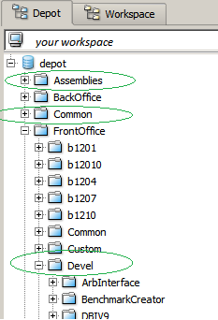

## Build Solutions required for Web App

This section is not required if you already built the projects with NANT

1. If you can’t or don’t want to build everything in NANT, the alternative is to Start Visual Studio, and
   * For each of the Bossware, Nii.JSON and Persistence solutions located in C:\PWS\Common :
   * Open the solution from the lastest versioned subfolder (i.e. NOT Devel)
     + For the warning about SCC Bindings not found - keep "temporarily work uncontrolled" checked.
   * Go to File > Source control > Change source control >
     + 1: Solution: Bind - browse to workspace – OK
     + 2: Project : Bind - OK
   * OK to "check out for edit" -- Keep "Protect" ticked -- OK
   * Build in RELEASE
   * On the solution, in the solution explorer window, right click and select Undo-Checkout

* Similar to above steps build the following projects
  + Hrml – FrontOffice\Devel\Hrml (note the Common\Hrml is deprecated as of Oct 2012)
  + ArbInterface – Common\ODS\ArbInterface (use the latest versioned – currently V2.0.0)
  + HrmlDbUtils – FrontOffice\Devel\HrmlService\HrmlDbUtils
  + HrmlWebControls – FrontOffice\Devel\HrmlWebControls
  + InfoHRM.Security – FrontOffice\**Common**\Infohrm.Security (use V1.0.0) – (dataprotectionproxy)
  + HrmlJobCommon – FrontOffice\Devel\HrmlJobService\HrmlJobCommon   
    NOTE only the **JobCommon project** will compile at this point – ignore the other projects/ solution until after you compile the DataObj in the web app.